Interest-Group Influence and U.S. Middle East Policy: Assessing Pro-Israel Advocacy, Campaign Finance, and Institutional Constraints

Syed Sharjeel Ali Bukhari

Department of Marketing & Business, Bahria University, Islamabad, Pakistan

Email: sharjeelshah100@gmail.com

Abstract
This study examines how organized pro-Israel advocacy contributes to the formation and maintenance of U.S. Middle East policy, with particular attention to congressional politics, campaign finance, information provision, coalition building, and the institutional constraints that limit or amplify interest-group influence. Rather than treating the so-called “Israel lobby” as a single actor or assuming that lobbying determines U.S. policy, the study conceptualizes influence as one component of a broader policy-production system in which interest groups interact with legislators, executive agencies, parties, voters, strategic interests, and established U.S.–Israel institutions. Using qualitative analysis of peer-reviewed scholarship, congressional records, public-opinion surveys, and campaign-finance evidence available through 2024, the paper develops an integrated analytical framework. The evidence suggests that pro-Israel advocacy is most consequential when its preferences overlap with existing congressional preferences, when it can provide political information or electoral resources, and when policy entrepreneurs inside government are receptive to its objectives. The 2024 evidence also indicates that the political environment was becoming more contested: Americans remained divided over military assistance to Israel, while support for humanitarian assistance to Palestinians and restrictions on the use of U.S. military aid gained substantial support. The study therefore rejects both extremes—that lobbying is irrelevant and that lobbying alone explains U.S. policy. Its principal contribution is a conditional model of influence that places advocacy within domestic institutions and strategic constraints.
Keywords: U.S. foreign policy; interest groups; lobbying; AIPAC; campaign finance; Congress; Israel; Middle East; political influence
Introduction:
The relationship between the United States and Israel has remained one of the most durable partnerships in American foreign policy. Its continuity has attracted extensive scholarly attention because U.S. support for Israel spans military assistance, diplomatic coordination, intelligence cooperation, missile-defense programs, trade, and political engagement. The persistence of this relationship has also generated debate about the role of organized domestic interests in shaping foreign-policy outcomes. Among the most visible actors are pro-Israel advocacy organizations, including the American Israel Public Affairs Committee (AIPAC), J Street, Christians United for Israel, and a wider network of political and civic groups.
The analytical problem is not whether advocacy organizations seek to influence policy—they clearly do—but how much influence they exercise, through which mechanisms, under what conditions, and relative to competing explanations. Interest-group scholarship cautions against interpreting lobbying as a simple transaction in which money purchases votes. Hall and Deardorff (2006), for example, conceptualize lobbying as a legislative subsidy that supplies information, political intelligence, and policy labor to legislators whose preferences may already be compatible with the lobbyist’s goals. This perspective is particularly useful for foreign-policy lobbying because many issues are technically complex and legislators face limited staff resources.
The influential argument of Mearsheimer and Walt (2007) places pro-Israel advocacy at the center of the explanation for the unusually close U.S.–Israel relationship. Their thesis remains important because it explicitly treats domestic political actors as a causal factor rather than as background noise. However, a stronger research design should avoid assuming the conclusion in the research question. Strategic considerations, institutional path dependence, presidential preferences, bipartisan ideology, public opinion, defense-industrial relationships, and long-standing legal and diplomatic arrangements also support U.S. policy toward Israel.
The October 7, 2023 attacks and the subsequent Gaza war provide an important stress test for these explanations. In 2024, Congress approved substantial additional security assistance for Israel, while public opinion became more divided. Pew Research Center reported that 36 percent of Americans favored military aid to Israel and 34 percent opposed it, while 50 percent favored humanitarian aid for Palestinian civilians. The Chicago Council's 2024 survey found that 53 percent supported restricting U.S. military aid to Israel so that it could not be used in military operations against Palestinians. These findings demonstrate that elite policy, organized advocacy, and mass opinion cannot be treated as identical forces.

Research Problem:
Existing discussions often suffer from two opposing weaknesses. Critical accounts sometimes attribute U.S. policy primarily to lobbying, while defensive accounts may reduce lobbying to ordinary democratic participation and understate the importance of organized political resources. Both approaches risk overlooking how advocacy and institutions interact. The research problem addressed here is therefore: how and under what conditions does pro-Israel advocacy affect U.S. Middle East policy, and what institutional and strategic factors constrain that influence?

Research Objectives:
- To identify the principal mechanisms through which pro-Israel advocacy can influence U.S. foreign-policy decision-making.
- To distinguish lobbying effects from strategic, institutional, partisan, and public-opinion explanations of U.S.–Israel policy.
- To assess the role of campaign finance and electoral incentives in congressional behavior through 2024.
- To examine whether the 2024 political environment indicates a changing domestic consensus regarding U.S. policy toward Israel.
- To develop an integrated analytical framework for understanding conditional interest-group influence.

Research Questions:
- RQ₁: Through which mechanisms do pro-Israel advocacy organizations seek to influence U.S. foreign policy?
- RQ₂: Under what conditions is advocacy likely to have a stronger effect on congressional and executive policy?
- RQ₃: To what extent can campaign finance, lobbying, and coalition building explain congressional support for Israel?
- RQ₄: How did public opinion in 2024 constrain or complicate pro-Israel advocacy?

Literature Review:

Interest Groups and Foreign Policy: Interest groups are a normal feature of pluralist democratic systems, but their influence varies across issues and institutions. Grossman and Helpman (2001) demonstrate how organized interests can shape public policy when political actors respond to organized constituencies and informational advantages. Hall and Deardorff (2006) add an important qualification: lobbyists often assist legislators who already have compatible preferences rather than converting opponents. This means observed correlation between lobbying activity and legislative behavior should not automatically be interpreted as proof of persuasion.
Foreign policy creates additional opportunities for organized interests because voters generally possess less detailed information about international issues than domestic economic questions. Baum and Potter (2008) show that public opinion and media coverage can influence foreign-policy decision-making, while Milner and Tingley (2015) emphasize that domestic political institutions shape foreign economic and foreign-policy choices. These perspectives suggest that interest groups operate inside a larger political environment rather than outside it.

The Pro-Israel Advocacy Debate: Mearsheimer and Walt (2007) argue that a broad coalition of pro-Israel actors has played a major role in sustaining U.S. support for Israel. Their contribution is useful for identifying mechanisms such as congressional lobbying, agenda setting, political mobilization, and the framing of policy debates. Critics of their approach, however, have emphasized that U.S.–Israel relations also reflect shared strategic interests, domestic political preferences, ideological affinities, and institutionalized security cooperation. The scholarly value of the debate therefore lies less in choosing between “lobby” and “strategy” as exclusive explanations and more in identifying how the factors interact.
A further conceptual issue is terminology. The phrase “Israeli lobby” can incorrectly imply that American Jewish citizens or Jewish organizations constitute a unified foreign-directed actor. This paper instead uses “pro-Israel advocacy” or “pro-Israel interest groups” when referring to organized political activity. This distinction is analytically important because American citizens, organizations, donors, churches, think tanks, and political committees can support Israel for different reasons and do not necessarily share identical policy preferences.
Campaign Finance and Political Access: Campaign finance is best understood as one mechanism of access and electoral signaling rather than as a mechanical purchase of policy. The broader literature finds that contributions can facilitate access, reinforce relationships, and help politicians respond to organized constituencies. In the pro-Israel case, the formation of AIPAC's political action committee in 2021 and the emergence of the United Democracy Project expanded the range of electoral tools available to pro-Israel political networks. By 2024, these tools were visible in congressional primary contests, where outside spending could reward candidates perceived as supportive of Israel or oppose candidates perceived as insufficiently supportive.
Strategic and Institutional Explanations: A purely domestic-politics explanation is also insufficient. U.S. policy toward Israel is embedded in formal security agreements, military procurement arrangements, intelligence cooperation, and broader Middle East strategy. Congress has repeatedly legislated military and missile-defense assistance, while executive administrations have maintained extensive bilateral security institutions. The 2016 U.S.–Israel Memorandum of Understanding established a framework for $38 billion in security assistance over FY2019–FY2028, including $33 billion in Foreign Military Financing and $5 billion for missile defense. Such institutionalized commitments create policy inertia that cannot reasonably be attributed to lobbying alone.
Theoretical Framework:
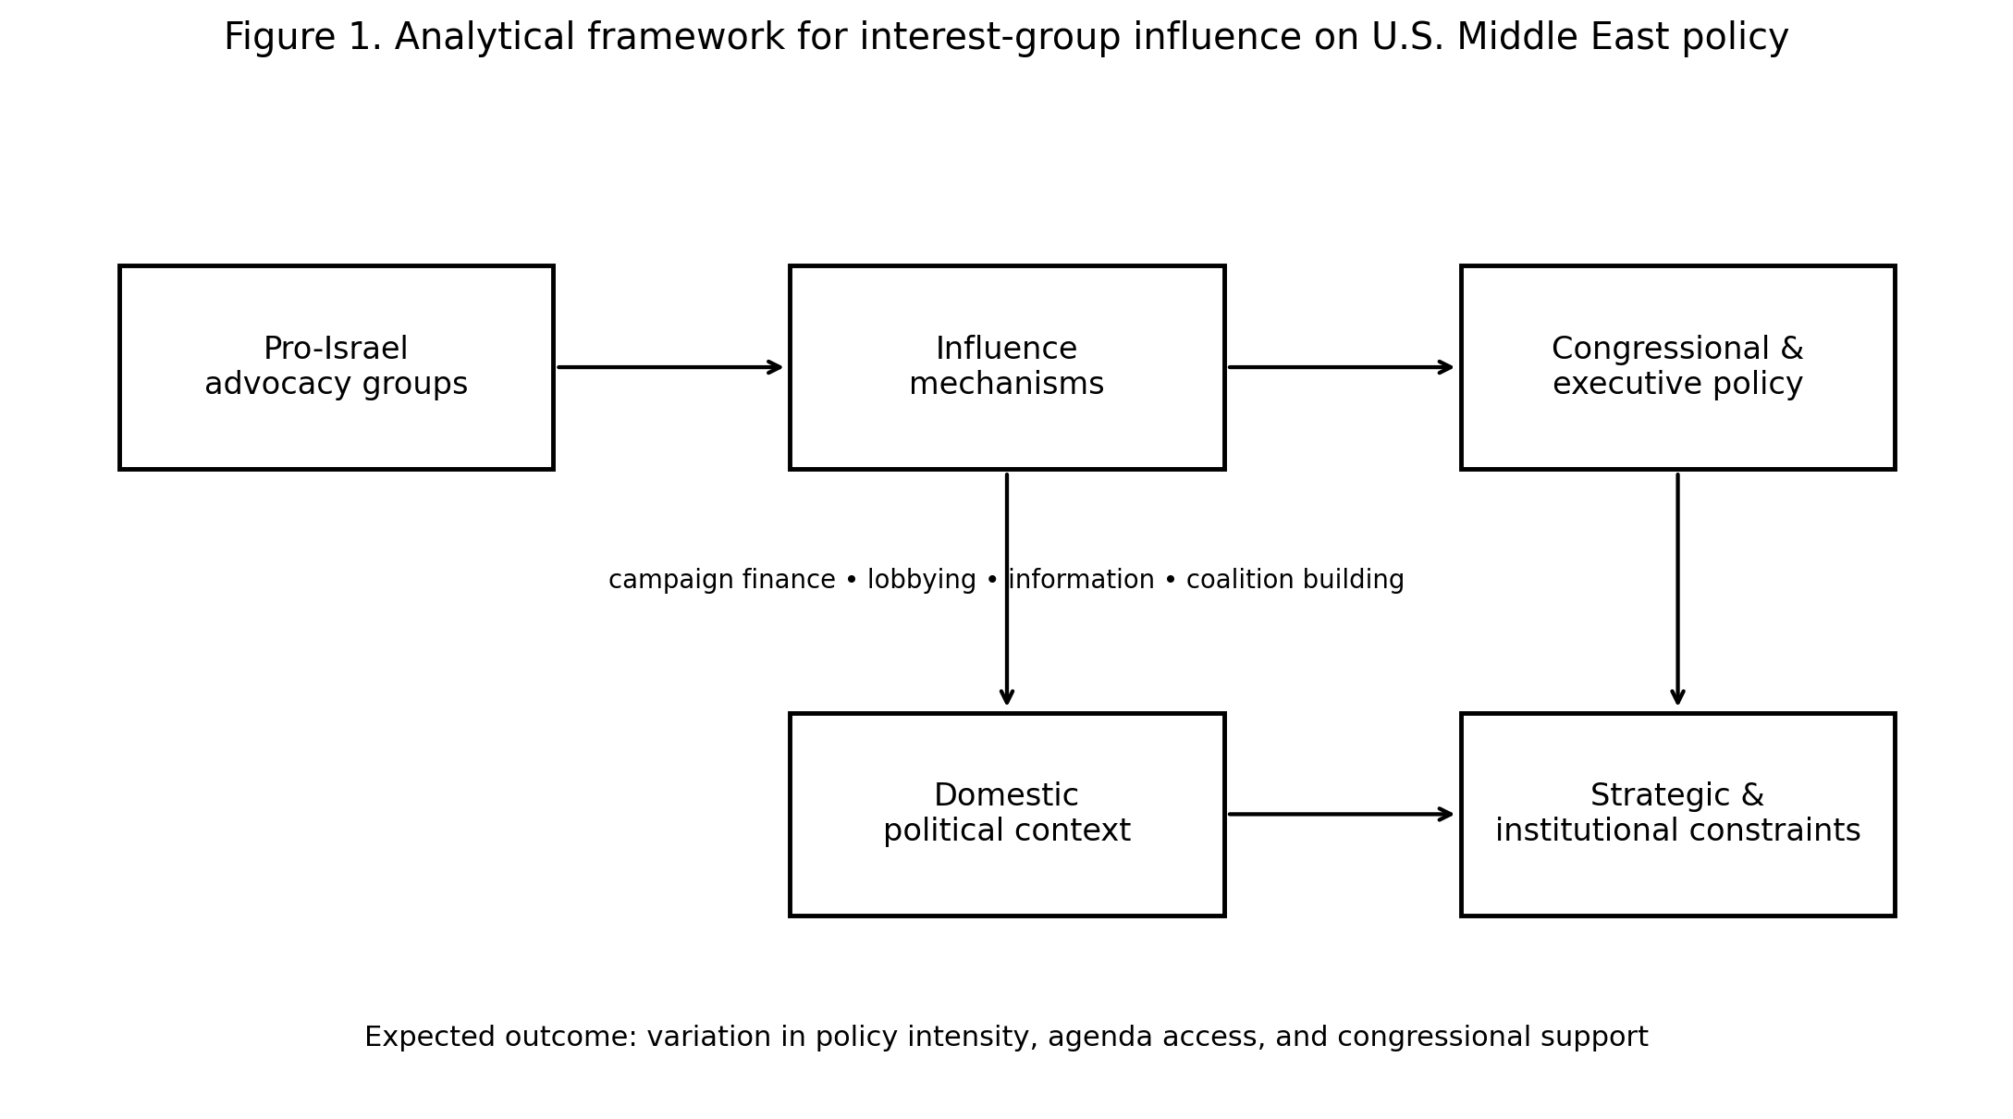
Figure 1: Analytical framework for interest-group influence on U.S. Middle East policy.
The study integrates pluralist interest-group theory with the legislative-subsidy model of lobbying and an institutionalist understanding of foreign-policy continuity. The central proposition is that advocacy is most effective when three conditions coincide: (1) the advocate's policy preferences overlap with those of influential decision-makers; (2) the advocate can provide electoral, informational, or organizational resources; and (3) competing institutions or public pressures do not impose strong countervailing constraints.
Accordingly, lobbying is treated as a conditional intervening mechanism rather than a sufficient cause. The dependent variable is policy responsiveness, operationalized through congressional support, agenda access, legislative outcomes, diplomatic positioning, and the durability of security assistance. Independent explanatory factors include organized advocacy intensity, campaign resources, information provision, coalition breadth, strategic interests, partisan ideology, presidential preferences, and public opinion.
Methodology:
This research uses a qualitative secondary-data design. The evidence base consists of peer-reviewed academic literature, scholarly books, Congressional Research Service material, congressional records, reputable public-opinion surveys, and campaign-finance reporting available through December 31, 2024. The analysis does not use evidence published in 2025 or 2026 and does not reproduce or quote the source document supplied by the author.
A structured thematic approach was used to classify evidence into five categories: (1) lobbying and information provision; (2) campaign finance and electoral pressure; (3) coalition building and political mobilization; (4) strategic and institutional constraints; and (5) public-opinion constraints. Evidence was then compared across the literature to identify areas of convergence and disagreement.

Table 1: Theoretical perspectives used in the study
Perspective | Core mechanism | Expected effect | Limitation
Pluralism / interest groups | Organized preferences and political mobilization | Greater access and policy responsiveness | Groups compete with other interests
Legislative subsidy | Information, intelligence, policy labor, electoral resources | Supports aligned legislators | Does not imply persuasion of opponents
Institutionalism | Rules, path dependence, established programs | Policy continuity | May understate agency and political change
Strategic realism | Security interests and regional balance | Support for strategically valuable partners | Strategic interests are contested and interpreted politically
Public-opinion model | Voter preferences and partisan coalitions | Constrains or enables policy choices | Foreign-policy issues can be low-information for voters

Findings and Analysis:

Lobbying as Access, Information, and Agenda Setting: The first finding is that lobbying should be understood primarily as a mechanism for shaping access and the policy environment. Pro-Israel organizations can provide legislators with policy briefs, talking points, legislative priorities, constituency information, and contacts with experts and affected communities. In a complex foreign-policy environment, these resources can lower the costs of policy development. This is consistent with Hall and Deardorff's (2006) legislative-subsidy model.
The mechanism becomes especially important when policymakers already possess broadly favorable attitudes toward Israel. In such cases, advocacy organizations do not need to transform preferences; they can help translate existing preferences into legislative action. This helps explain why a lobby may appear highly influential without necessarily changing the minds of a large number of opponents. The causal effect is often agenda reinforcement and coordination.
Campaign Finance and Electoral Incentives: The second finding concerns electoral politics. The creation of AIPAC's PAC and the United Democracy Project changed the political toolkit available to pro-Israel advocates. During the 2024 cycle, the United Democracy Project had raised approximately $68.4 million by late September and spent approximately $56 million, including more than $35.6 million in independent expenditures. Its spending was concentrated heavily in congressional primary contests, demonstrating the importance of candidate selection—not only general election outcomes—as a mechanism of influence (FactCheck.org, 2024).
This evidence should not be interpreted as proof that campaign spending automatically determines votes. Primary elections provide a particularly useful setting for interest-group influence because turnout is lower, political information is more specialized, and relatively modest financial investments can alter the competitive environment. The likely mechanism is therefore deterrence and candidate selection: politicians may anticipate the electoral consequences of taking positions that powerful organized networks strongly oppose.

Congressional Policy and the 2024 Security Supplemental: The 2024 congressional response provides an important policy test. On April 23, 2024, the Senate approved the emergency supplemental package by 79–18, following House action. The Israel-related provisions included $3.5 billion in Foreign Military Financing and $5.2 billion for missile-defense programs, including $4 billion for missile defense and $1.2 billion for the Iron Beam program. The scale of the package illustrates the continuing institutional strength of U.S.–Israel security cooperation.
However, the legislative outcome cannot be attributed to AIPAC or any single advocacy organization. Congressional support reflected multiple considerations: the security relationship, concerns about regional escalation, bipartisan views of Israel's security, presidential preferences, defense policy, and pressure from organized constituencies. The appropriate conclusion is therefore that pro-Israel advocacy operated within a policy environment already structured to be receptive to substantial security assistance.
Public Opinion as a Countervailing Constraint: Public opinion in 2024 complicates the argument that organized pro-Israel advocacy faces no meaningful constraint. Pew Research Center found that 36 percent of Americans favored U.S. military aid to Israel while 34 percent opposed it; 50 percent favored humanitarian aid for Palestinian civilians, and 55 percent supported a U.S. diplomatic role in ending the war. The Chicago Council's 2024 survey reported that 53 percent favored restricting U.S. military aid to Israel so that it could not be used in military operations against Palestinians. These results indicate that the American electorate was not uniformly aligned behind unconditional support.
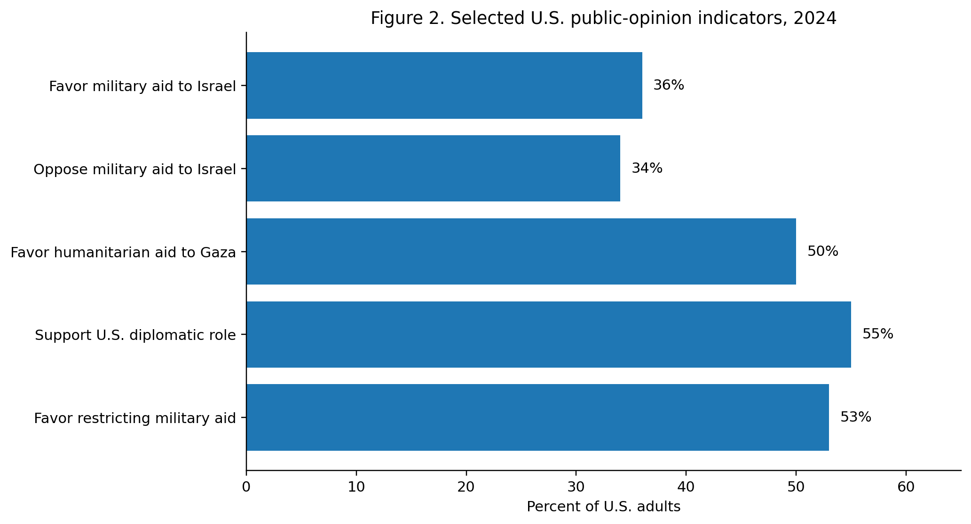
Figure 2: Selected U.S. public-opinion indicators, 2024

Partisanship and the Changing Political Coalition: The 2024 evidence also reveals a growing partisan divergence. Pew found that Republicans were considerably more supportive of military assistance to Israel than Democrats, while younger Americans were more skeptical of military aid. The Chicago Council survey similarly found that Democratic and independent respondents were more supportive of restrictions on military assistance. This matters because lobbying effectiveness depends partly on the political coalition available to an advocacy organization.

Table 2: Major channels of pro-Israel political influence
Channel | How it operates | Likely policy effect | Strength of evidence through 2024
Direct lobbying | Meetings, legislative advocacy, policy briefs | Agenda access; reinforcement of aligned legislators | High
Campaign finance | PAC contributions and electoral spending | Access, deterrence, candidate selection | Moderate–High
Independent expenditures | Advertising and opposition/support in elections | Changes electoral competitiveness | Moderate–High
Coalition building | Partnerships across parties, religious and civic networks | Broadens constituency for policy | Moderate
Information provision | Policy expertise, talking points, research | Reduces information costs | High
Public messaging | Media, grassroots mobilization, issue framing | Shapes agenda and political salience | Moderate
Institutional relationships | Long-term security and diplomatic ties | Creates policy continuity | High, but not attributable to lobbying alone
A major implication is that the long-term effectiveness of pro-Israel advocacy may depend less on the absolute amount of money spent than on its ability to operate across changing partisan coalitions. Historically, strong bipartisan support created favorable conditions for Israel-related legislation. By 2024, however, differences between party coalitions and generations had become more visible. This does not mean that the underlying U.S.–Israel relationship was collapsing; rather, the political basis for maintaining it was becoming more contested.

Table 3: Selected 2024 indicators relevant to the policy environment
Indicator | 2024 finding | Interpretation
Military aid to Israel | 36% favor; 34% oppose | No clear national consensus on military aid
Humanitarian aid to Gaza | 50% favor; 19% oppose | Humanitarian assistance had broader support
U.S. diplomatic role | 55% wanted some U.S. role | Demand for diplomatic engagement remained substantial
Restriction of U.S. military aid | 53% support | A meaningful constituency favored conditions on aid
American Jewish support for U.S. support to Israel | 85% considered support important | Strong support within an important constituency, while not representing all Americans

Discussion:
The evidence supports a conditional rather than deterministic interpretation of pro-Israel influence. First, organized advocacy has genuine capacity to affect policy because it can mobilize resources, provide information, coordinate legislators, and shape electoral incentives. Second, its effectiveness is greatest when policymakers are already sympathetic to the policy objective. Third, institutionalized U.S.–Israel security cooperation makes it difficult to separate contemporary lobbying from decades of accumulated policy commitments.
The analysis therefore suggests a four-part causal sequence. Advocacy organizations identify policy priorities; they mobilize information, coalition resources, and electoral incentives; receptive policymakers translate these resources into legislative or executive action; and institutional structures then stabilize the resulting policy. At each stage, however, countervailing forces can intervene. These include presidential preferences, competing interest groups, partisan changes, public opinion, legal constraints, international events, and the strategic calculations of the executive branch.
The 2024 Gaza war illustrates this interaction particularly clearly. Congress continued to provide major security assistance, but public opinion increasingly questioned the conditions and scale of that support. The result was not a simple replacement of one foreign-policy consensus with another. Instead, the policy debate became more multidimensional: support for Israel's security could coexist with support for humanitarian assistance to Palestinians and restrictions on the use of U.S. weapons.
A further implication concerns the meaning of political influence. Influence should not be measured only by whether a particular bill passes. It can also appear as agenda access, the selection of policy alternatives, the avoidance of certain legislative proposals, the electoral survival of aligned politicians, and the maintenance of a policy baseline. This broader definition provides a better explanation of how organized interests can matter without possessing unilateral control over foreign policy.
Table 4: Testable propositions derived from the analytical framework
Proposition | Statement
P₁ | Greater alignment between a legislator's prior preferences and pro-Israel policy positions will strengthen the effect of lobbying on legislative behavior.
P₂ | Pro-Israel electoral spending will have stronger effects in low-information, competitive primary elections than in highly salient national elections.
P₃ | The effect of campaign contributions will be mediated by access and candidate selection rather than operating primarily through direct vote purchase.
P₄ | Institutionalized U.S.–Israel security arrangements will reduce the marginal effect of any single advocacy organization on aggregate policy outcomes.
P₅ | Increasing partisan and generational divergence over Israel will reduce the durability of a uniformly bipartisan policy consensus.

Conclusion:
This paper has argued that pro-Israel advocacy is a meaningful component of U.S. Middle East policymaking, but it is neither the only nor necessarily the dominant explanation for every policy outcome. Its influence is most plausibly understood through a conditional model in which lobbying, campaign finance, information provision, coalition building, and electoral incentives interact with strategic interests, institutional commitments, partisan preferences, presidential priorities, and public opinion.
The 2024 evidence is particularly important because it demonstrates both continuity and contestation. The United States maintained a deep security relationship with Israel and Congress authorized substantial additional assistance. At the same time, national public opinion was divided over military aid and increasingly supportive of humanitarian assistance and restrictions on the use of U.S. military support. These developments suggest that the domestic political foundations of U.S. Middle East policy are becoming more differentiated across parties and generations.
For scholarship, the central lesson is methodological: researchers should avoid attributing complex foreign-policy outcomes to a single lobby. A stronger approach identifies the specific mechanism, the relevant institution, the competing interests, and the counterfactual. Future research should combine congressional roll-call data, campaign-finance records, lobbying disclosures, interviews, and public-opinion data to estimate whether lobbying changes policy preferences or primarily reinforces pre-existing ones. Such an approach can move the debate from polarized claims about “control” toward a more testable account of political influence.
Limitations:
- The study is based on secondary evidence and therefore cannot directly observe private lobbying interactions or policymakers' motivations.
- Campaign spending is easier to measure than causal influence; high spending may reflect competitive races rather than cause electoral outcomes.
- Public-opinion surveys measure attitudes at specific points in time and may change rapidly during international crises.
- The paper uses an evidence cutoff of December 31, 2024 and therefore does not incorporate subsequent developments.
- The term pro-Israel advocacy covers a heterogeneous set of organizations and individuals whose preferences are not identical.

References
American Jewish Committee. (2024). AJC’s 2024 survey of American Jewish opinion. https://www.ajc.org/survey2024
Baum, M. A., & Potter, P. B. K. (2008). The relationships between mass media, public opinion, and foreign policy: Toward a theoretical synthesis. Annual Review of Political Science, 11, 39–65. https://doi.org/10.1146/annurev.polisci.11.060406.214132
Bawn, K., Cohen, M., Karol, D., Masket, S., Noel, H., & Zaller, J. (2012). A theory of political parties: Groups, policy demands and nominations in American politics. Perspectives on Politics, 10(3), 571–597. https://doi.org/10.1017/S1537592712001624
Chicago Council on Global Affairs. (2024). America’s foreign policy future: Public opinion and the 2024 election. https://globalaffairs.org/research/public-opinion-survey/americas-foreign-policy-future-public-opinion-and-2024-election
FactCheck.org. (2024, September 25). United Democracy Project. Annenberg Public Policy Center, University of Pennsylvania. https://www.factcheck.org/2024/09/united-democracy-project/
Grossman, G. M., & Helpman, E. (2001). Special interest politics. MIT Press. MIT Press: Special Interest Politics
Gultom, Y. S. M., and Miftah, H. Z. (2024). The role of the Jewish lobby toward U.S. foreign policymaking on the 2023 Israel-Palestine War (Case of AIPAC). Hasanuddin Journal of Strategic and International Studies, 2(2), 38–49. https://doi.org/10.20956/hjsis.v2i2.34405
Hall, Richard L., and Alan V. Deardorff. (2006). Lobbying as legislative subsidy. American Political Science Review, 100(1), 69–84. https://doi.org/10.1017/S0003055406062010
Hertel-Fernandez, A. (2019). State capture: How conservative activists, big businesses, and wealthy donors reshaped the American states—and the nation. Oxford University Press.
Lowery, D. (2007). Why do organized interests lobby? A multi-goal, multi-context theory of lobbying. Polity, 39(1), 29–54. https://doi.org/10.1057/palgrave.polity.2300077
Mearsheimer, J. J., & Walt, S. M. (2007). The Israel lobby and U.S. foreign policy. Farrar, Straus and Giroux.
Milner, H. V., & Tingley, D. (2015). Sailing the water’s edge: The domestic politics of American foreign policy. Princeton University Press.
Pew Research Center. (2024, March 21). Views of the U.S. role in the Israel-Hamas war. Pew Research Center
Pew Research Center. (2024, October 1). On Israel-Hamas war, slightly more Americans now say U.S. should help diplomatically. Pew Research Center
U.S. Congressional Research Service. (2024, October 4). Israel and Hamas conflict in brief: Overview, U.S. policy, and options for Congress (R47828). Congressional Research Service. Congressional Research Service report
U.S. Congressional Research Service. (2024). U.S. foreign aid to Israel: Overview and developments since October 7, 2023 (RL33222). Congressional Research Service. CRS report—U.S. Foreign Aid to Israel
United States Congress. (2024, April 24). Making emergency supplemental appropriations for the fiscal year ending September 30, 2024, and for other purposes (Pub. L. No. 118-50). U.S. Government Publishing Office. GovInfo—Public Law 118-50
Walt, S. M., & Mearsheimer, J. J. (2006). The Israel lobby and U.S. foreign policy (HKS Faculty Research Working Paper Series, RWP06-011). Harvard Kennedy School. Harvard Kennedy School—Working Paper RWP06-011

Sources: Pew Research Center (2024); Chicago Council on Global Affairs (2024).
Figure 2 and Table 3 use 2024 survey findings from Pew Research Center, the Chicago Council on Global Affairs, and the American Jewish Committee. The congressional figures are based on 2024 Congressional Research Service and congressional records. The electoral-spending discussion uses 2024 reporting from FactCheck.org based on campaign-finance records. All substantive evidence in this paper is limited to information available by December 31, 2024.
Note: Survey questions, samples, field dates, and wording differ across organizations; the figures should therefore be interpreted as indicators of the political environment rather than as directly comparable measurements of one latent construct.

